**WITH NOISE AND WITHOUT FILTER FUZZY**

**Image set:**

|  |
| --- |
| **Image 1:-0.1 % Noise** |

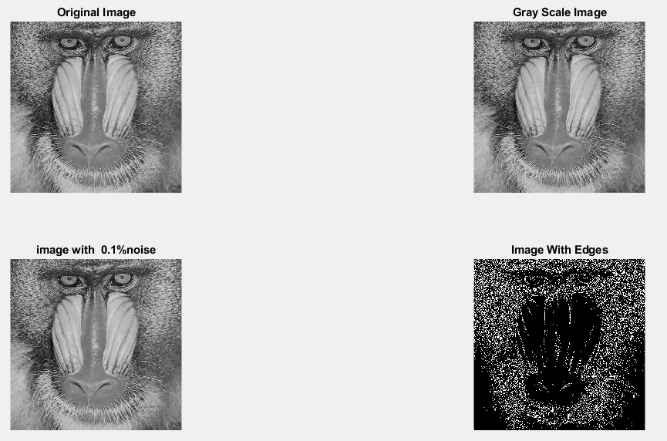

**Image 2:-10 % Noise**

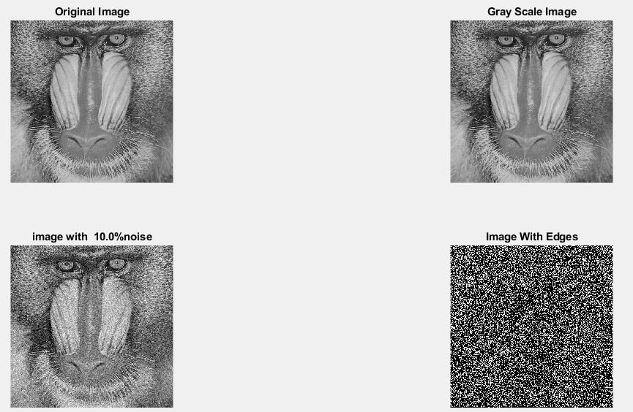

**Image 3:-20 % Noise**

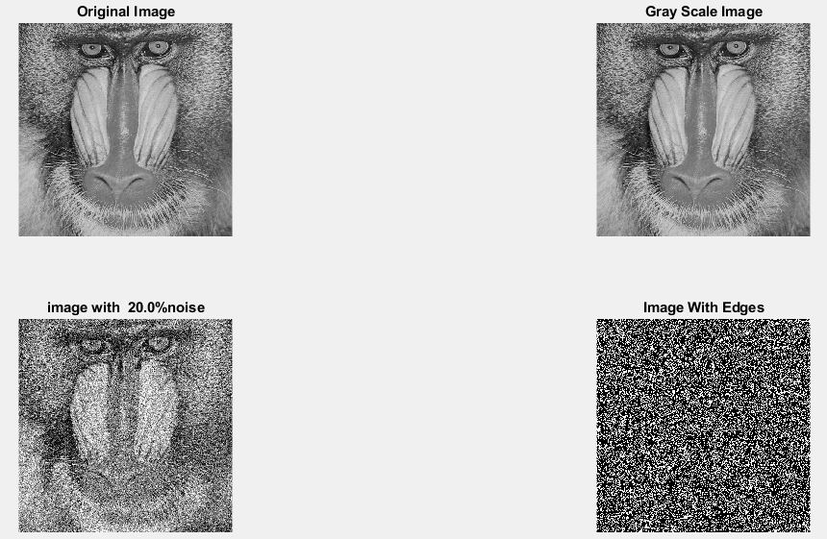

**Image 4:-30 % Noise**

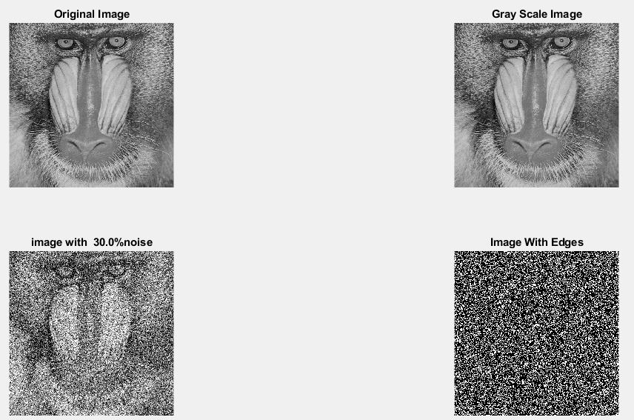

|  |
| --- |
| **Image 5:-40 % Noise** |

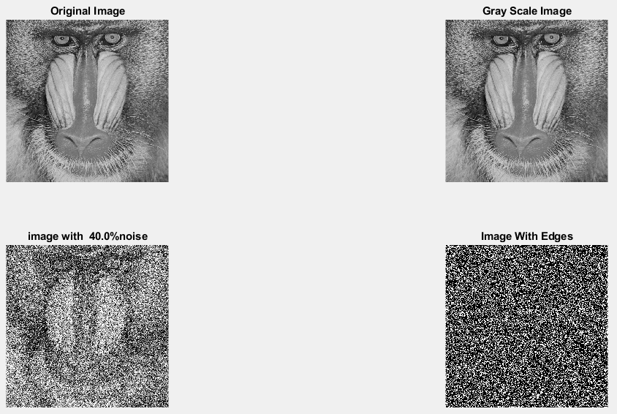

**Image 6:-50 % Noise**

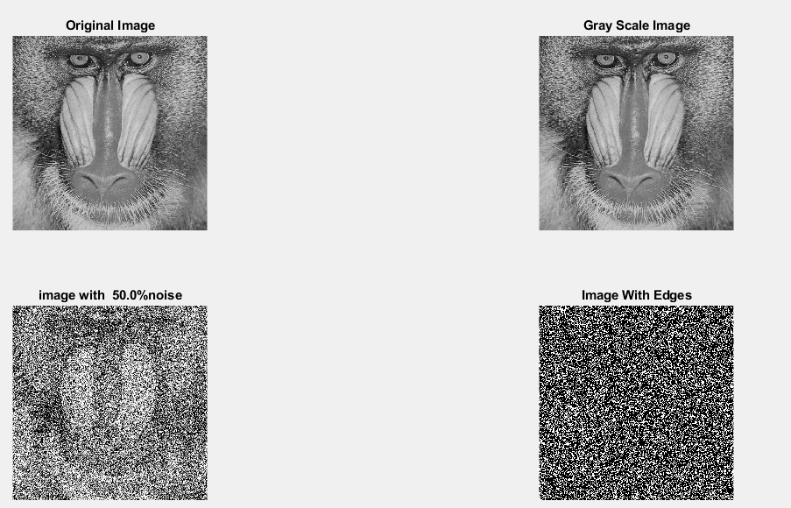

**Image 7:-60 % Noise**

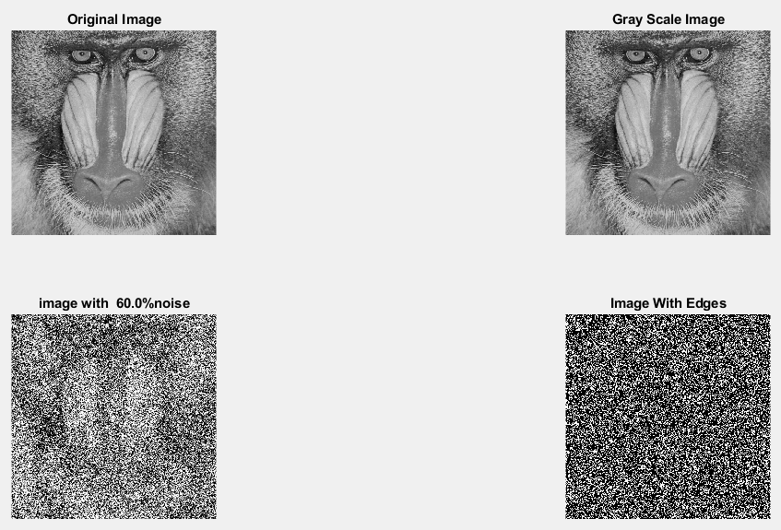

**Image 8:-70 % Noise**

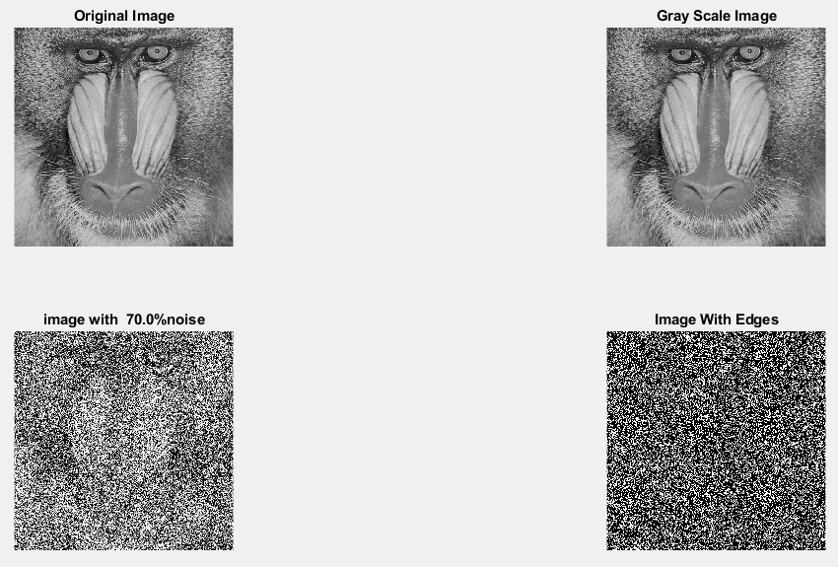

**Image 9:-80 % Noise**

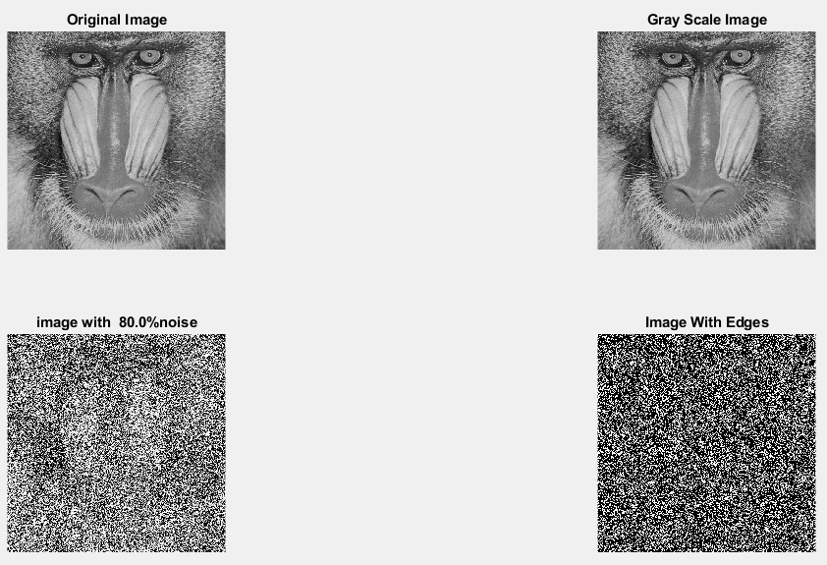

**DATA FILES**

**Image 1:-Noise0.1**

Original image ideal values:

IM1 image entropy:6.759883e-01

IM1 image mean:0.178139

Ground truth image entropy:0.943520

Ground truth image mean:0.361012

entropy between imt and im1 :0.872424

MSE between imt and im1 :0.402905

Average Difference between imt and im1 :0.182873

Maximum Difference between imt and im1 :1.000000

True Positive values:17858.000000

False Positive values: 28840.000000

True Negative values:138667.000000

False Negative values:76779.000000

Accuracy value: 0.597095

F Measure values:0.252705

Peak Signal-to Noise Ration value: 3.947979

Signal-to Noise Ration value: -3.067627

percentage of pixels that were correctly detected (Pco): 0.188700

The percentage of pixels that were not detected (Pnd):0.811300

the percentage of false alarm: (Pfa):0.304743

Euclidean Distance Value :17.910345

**Image 2:-Noise10**

Original image ideal values:

IM1 image entropy:8.997892e-01

IM1 image mean:0.315830

Ground truth image entropy:0.943520

Ground truth image mean:0.361012

entropy between imt and im1 :0.810976

MSE between imt and im1 :0.454437

Average Difference between imt and im1 :0.045181

Maximum Difference between imt and im1 :1.000000

True Positive values:29151.000000

False Positive values: 53642.000000

True Negative values:113865.000000

False Negative values:65486.000000

Accuracy value: 0.545563

F Measure values:0.328592

Peak Signal-to Noise Ration value: 3.425261

Signal-to Noise Ration value: -0.580673

percentage of pixels that were correctly detected (Pco): 0.308030

The percentage of pixels that were not detected (Pnd):0.691970

the percentage of false alarm: (Pfa):0.566818

Euclidean Distance Value :29.825372

**Image 3:-Noise20**

Original image ideal values:

IM1 image entropy:9.164642e-01

IM1 image mean:0.331512

Ground truth image entropy:0.943520

Ground truth image mean:0.361012

entropy between imt and im1 :0.799637

MSE between imt and im1 :0.456066

Average Difference between imt and im1 :0.029499

Maximum Difference between imt and im1 :1.000000

True Positive values:30993.000000

False Positive values: 55911.000000

True Negative values:111596.000000

False Negative values:63644.000000

Accuracy value: 0.543934

F Measure values:0.341444

Peak Signal-to Noise Ration value: 3.409722

Signal-to Noise Ration value: -0.370212

percentage of pixels that were correctly detected (Pco): 0.327493

The percentage of pixels that were not detected (Pnd):0.672507

the percentage of false alarm: (Pfa):0.590794

Euclidean Distance Value :31.770043

**Image 4:-Noise30**

Original image ideal values:

IM1 image entropy:9.180579e-01

IM1 image mean:0.333096

Ground truth image entropy:0.943520

Ground truth image mean:0.361012

entropy between imt and im1 :0.799355

MSE between imt and im1 :0.457306

Average Difference between imt and im1 :0.027916

Maximum Difference between imt and im1 :1.000000

True Positive values:31038.000000

False Positive values: 56281.000000

True Negative values:111226.000000

False Negative values:63599.000000

Accuracy value: 0.542694

F Measure values:0.341159

Peak Signal-to Noise Ration value: 3.397932

Signal-to Noise Ration value: -0.349522

percentage of pixels that were correctly detected (Pco): 0.327969

The percentage of pixels that were not detected (Pnd):0.672031

the percentage of false alarm: (Pfa):0.594704

Euclidean Distance Value :31.817616

**Image 5:-Noise40**

Original image ideal values:

IM1 image entropy:9.219132e-01

IM1 image mean:0.336994

Ground truth image entropy:0.943520

Ground truth image mean:0.361012

entropy between imt and im1 :0.795557

MSE between imt and im1 :0.456604

Average Difference between imt and im1 :0.024017

Maximum Difference between imt and im1 :1.000000

True Positive values:31641.000000

False Positive values: 56700.000000

True Negative values:110807.000000

False Negative values:62996.000000

Accuracy value: 0.543396

F Measure values:0.345845

Peak Signal-to Noise Ration value: 3.404603

Signal-to Noise Ration value: -0.298987

percentage of pixels that were correctly detected (Pco): 0.334341

The percentage of pixels that were not detected (Pnd):0.665659

the percentage of false alarm: (Pfa):0.599131

Euclidean Distance Value :32.454219

**Image 6:-Noise50**

Original image ideal values:

IM1 image entropy:9.241566e-01

IM1 image mean:0.339310

Ground truth image entropy:0.943520

Ground truth image mean:0.361012

entropy between imt and im1 :0.793549

MSE between imt and im1 :0.456509

Average Difference between imt and im1 :0.021702

Maximum Difference between imt and im1 :1.000000

True Positive values:31957.000000

False Positive values: 56991.000000

True Negative values:110516.000000

False Negative values:62680.000000

Accuracy value: 0.543491

F Measure values:0.348144

Peak Signal-to Noise Ration value: 3.405510

Signal-to Noise Ration value: -0.269248

percentage of pixels that were correctly detected (Pco): 0.337680

The percentage of pixels that were not detected (Pnd):0.662320

the percentage of false alarm: (Pfa):0.602206

Euclidean Distance Value :32.787852

**Image 7:-Noise60**

Original image ideal values:

IM1 image entropy:9.267980e-01

IM1 image mean:0.342083

Ground truth image entropy:0.943520

Ground truth image mean:0.361012

entropy between imt and im1 :0.791620

MSE between imt and im1 :0.456978

Average Difference between imt and im1 :0.018929

Maximum Difference between imt and im1 :1.000000

True Positive values:32259.000000

False Positive values: 57416.000000

True Negative values:110091.000000

False Negative values:62378.000000

Accuracy value: 0.543022

F Measure values:0.350048

Peak Signal-to Noise Ration value: 3.401049

Signal-to Noise Ration value: -0.233896

percentage of pixels that were correctly detected (Pco): 0.340871

The percentage of pixels that were not detected (Pnd):0.659129

the percentage of false alarm: (Pfa):0.606697

Euclidean Distance Value :33.106738

**Image 8:-Noise70**

Original image ideal values:

IM1 image entropy:9.284439e-01

IM1 image mean:0.343838

Ground truth image entropy:0.943520

Ground truth image mean:0.361012

entropy between imt and im1 :0.789880

MSE between imt and im1 :0.456665

Average Difference between imt and im1 :0.017174

Maximum Difference between imt and im1 :1.000000

True Positive values:32530.000000

False Positive values: 57605.000000

True Negative values:109902.000000

False Negative values:62107.000000

Accuracy value: 0.543335

F Measure values:0.352110

Peak Signal-to Noise Ration value: 3.404022

Signal-to Noise Ration value: -0.211675

percentage of pixels that were correctly detected (Pco): 0.343734

The percentage of pixels that were not detected (Pnd):0.656266

the percentage of false alarm: (Pfa):0.608694

Euclidean Distance Value :33.392859

**Image 9:-Noise80**

Original image ideal values:

IM1 image entropy:9.322999e-01

IM1 image mean:0.348034

Ground truth image entropy:0.943520

Ground truth image mean:0.361012

entropy between imt and im1 :0.787380

MSE between imt and im1 :0.457909

Average Difference between imt and im1 :0.012978

Maximum Difference between imt and im1 :1.000000

True Positive values:32917.000000

False Positive values: 58318.000000

True Negative values:109189.000000

False Negative values:61720.000000

Accuracy value: 0.542091

F Measure values:0.354190

Peak Signal-to Noise Ration value: 3.392212

Signal-to Noise Ration value: -0.158995

percentage of pixels that were correctly detected (Pco): 0.347824

The percentage of pixels that were not detected (Pnd):0.652176

the percentage of false alarm: (Pfa):0.616228

Euclidean Distance Value :33.801545